AUVSI 2019: UAVOS pushing unmanned helicopters for lidar ops
30th April 2019 - 17:54 GMT | by Helen Haxell in Chicago

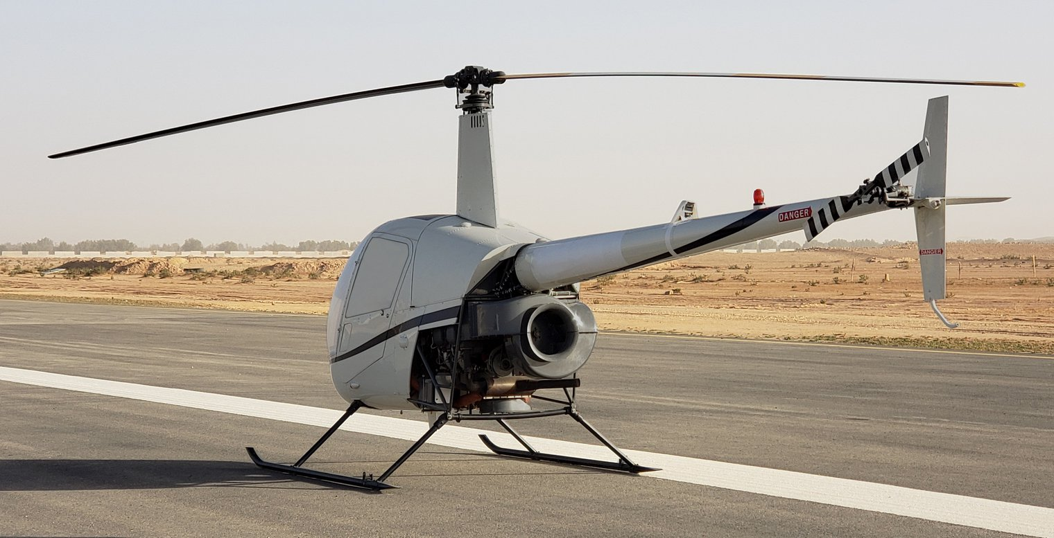

The future of lidar missions in oil and gas, mapping to power line inspections could very much be in the hands of unmanned helicopters, further to a conversion initiative which is being led by UAVOS through its exploration of transferring technology from light single engine helicopters to unmanned.
The company unveiled at AUVSI’s Xponential that in February 2019 it had flown for the first time a converted Robinson R22 to an unmanned state of operation. The flight of 1hr saw the platform reach up to 650m above sea level.
One of the main motivations behind this unmanned platform is to carry heavy payload equipment from optical systems to lidar to SAR.
UAVOS is seeking to explore other rotary-wing platforms for unmanned conversions, Aliaksei Stratsilatau, chair of the board at UAVOS, told Shephard: ‘We are looking at other helicopters and are interested in Schweizer.’ He said how the company was looking to discover helicopters where the full technology could be purchased.
Back in the rotary-wing market, Sikorsky’s sold its S-300 and S-333 light helicopter product line to Schweizer RSG in January 2018. In March 2019, the company announced a signing agreement for 25 S-300CBI light-single helicopters to International Defense and Aerospace Group.
Stratsilatau stated that unmanned helicopters were ideal platforms for oil and gas operations, agricultural mapping, powerline and gas pipeline inspections because ‘helicopters can avoid collisions due to their autorotation capabilities’.
UAVOS has conducted the unmanned conversion of the rotary-wing platform based on a customer’s interest but now the company will continue this as its own R&D programme. Next steps will include the conversion of another R22 at the company’s Spanish facility.
Whilst the original conversion of the inaugural R22 took two years from the concept stage, the next transformation will take around two months from manned to unmanned because as Stratsilatau explained the technology is now there thus reducing the manufacturing time.
Other technology capabilities being considered include the placement of a special antenna on the top of the aircraft or the cabin. In addition, UAVOS is looking at further integration improvements, external datalinks and the introduction of SATCOM.
The R22 being the initial helicopter to be experimented with unmanned technology by UAVOS was due to the global presence of the platform which, in turn, equates to multiple service workshops and facilities therefore a widely available set of spare parts and ground maintenance possibilities.
Furthermore, he added, the purchasing price for the Robinson platform makes it more economically viable as a research platform at around $70,000. The R22 is in its 40th year of production and over the course of 2017 to 2018, the OEM has sold 67 aircraft in that two-year timeframe alone. The project by UAVOS is completely independent from Robinson Helicopter.
With the UAVOS payload added to the platform in replace of a human, weighing on average 70kg, there is no affect to the MTOW. The company for the conversion process installed servers, linkages as part of its payload but removed mechanical linkages and the pilot’s seat thus the interior becomes dedicated to the UAVOS payload alone.
Currently, the unmanned R22 can reach 100km line-of-sight.

